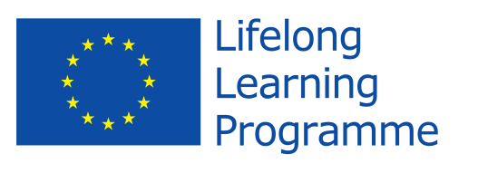
Leonardo da Vinci Transfer of Innovation
Project no. 2011-1-PL1-LEO05-19900
Strengthening Business Performance Management in Economic Networks (SeBPEN)

Development of SMEs through international cooperation of clusters
The knowledge exchange, good practices, partnership

International Conference
26th-27th September 2013

Venue:
Leszczyńskie Centrum Biznesu Sp. z o.o.
Ul Geodetów 1
64-100 Leszno

Agenda

26th September 2013 – Preconference

16.00Conference opening for the LdV projects participants – Project Manager Maciej Pietrzykowski

16.15- 16.30 Overview of the project – Project Manager Maciej Pietrzykowski

16.30 – 17.00 Coffee break

17.00-20.00 Presentations of the Personal Development Plans – projects participants from Poland and Lithuania

20.00 – 21.30 Diner

27th September 2013

09.00 – 09.30 Registration

09.30 – 09.35 Conference opening and welcome – President of the Leszno Town Tomasz Malepszy

09.35-09.50 Leszno Business Centre – overview – President of the LBC Alicja Szczepińska

09.50 – 10.10 Leonardo da Vinci Project SeBPEN – overview – Project Manager Maciej Pietrzykowski

10.10-11.10 Internationalisation of the clusters and other business network – step by step – Managing Partner of the Navigator Consulting Partner LLP, UK, Philipp Ammerman

11.10 – 11.40 Managing clusters and other business networks in Wielkopolska – Project Manager Maciej Pietrzykowski

11.40 – 11.50 Discussion

11.50– 12.05 Coffee break

12.05 -12.20 Cluster “Leszno Tastes” – promotion and cooperation for the highest quality, tradition and modern technologies in food industry in the south-west Wielkopolska - President of the LBC Alicja Szczepińska

12.20 - 12.50 How to prepare the food industry company, step by step, to the expansion on the German market Anna Pappert, PappertConsult, Berlin

12.50 -13.20 Services of the Polish Chamber of Commerce for Importers , Exporters and Cooperation in terms of support international cooperation of companies, Iwona Wesołek – Director PK KSU, the Polish Chamber of Commerce for Importers , Exporters and Cooperation

13.20-13.50 Lunch

13.50 -14.20 FoodRegio – the North German Food Cluster & our experiences in internationalization – Karolina Miler, LÜBECK Business Development Corp., Niemcy

14.20-14.50 Clusters – Networking and development prospects - Michaela Henzinger, Klaster Lebensmittel z Górnej Austrii, Linz, Austria

14.50 -15.20 Food Industry in Lithuania - - Gintautas Sironas, Kaunas University of Technology

15.20 – 15.30 Discussion

15.30 -15.45 Summary and closing of the conference – Alicja Szczepińska, Maciej Pietrzykowski

